C++ TraceTool API documentation

Table of contents
Introduction 1
Sample use 2
API documentation overview 5
TTrace 6
TTraceOptions 6
TraceToSend 6
TraceNode 6
TraceNodeEx 6
TMemberNode 6
WinTrace 7
WinWatch 7
Extend TraceTool with plugins 8

Introduction

License information: You are free to distribute the viewer (GPL) and to incorporate the library (LGPL) in your product (commercial or not).The only thing you can't do is to sell the viewer (or a modified version) and the API as a tracing solution.

Six frameworks are currently supported: Dot net (C#), Java , JavaScript, Delphi for window , C++ and ActiveX
Since theses languages are different, the syntax and the options are a little bit different.

C#: TTrace.Warning.Send ("Hello");
Java: TTrace.warning ().send ("hello");
Delphi: TTrace.Warning.Send ('hello');
C++: TTrace::Warning ()->Send ("Hello");
Javascript : ttrace.warning().send(“Hello”);
ActiveX : Depends from the host (script , VB, …)
See the corresponding TraceTool API documentation’s for more details on theses languages.

Note: if you want to use full TraceTool framework under Dot net, use the managed TraceTool library, not the C++ one!

The C++ library (for non managed applications) is a little bit different from the other libraries.
C++ language don’t have garbage collector and it’s not possible to inspect classes.
Some C++ Tracetool functions return void in place of trace node.

The entry point of the framework is the TTrace class.
That class provide 3 invisibles parents node (Debug, Warning and Error) with specific icon and with the “Enabled” property set to true.
TTrace as some global functions, like Clear () to clear all the traces and Show () to show or hide the viewer
The framework gives the possibility to create multiple Tab traces, see the WinTrace class.

TraceTool propose 2 ways to send traces:
- TraceNode
- TraceNodeEx

In TraceNode mode, traces are sent from a Parent node. (debug, warning and error)
It’s the quicker way to send simple traces.

The problem with TraceNode is that the class cannot provide hundreds of overload methods to match the developer needs.
For example Send (“Col1”, “Col2”, Type) or Send (“col1”, IconIndex) .
It’s where TraceNodeEx is needed.

In this mode, TraceNodeEx is created first, filled by the developer and then sent.
Using TraceNodeEx, you can specify left and right column separately, give an icon and add some information onto the “member” pane, like dumps, on a single trace.

If you want to separate your application traces and databases trace or Exceptions traces, you can create multiple windows traces
See the WinTrace classes and demos

This C++ library is compatible with pocket PC 2003. See the WinCeDemo workspace (Embedded C++ 4.0)

Sample use

Simple traces

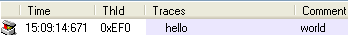

Using TraceNode

TTrace::Debug()->Send ("Hello world");
TTrace::Debug()->Send ("Hello", "world");

Note that the icon is the same as TTrace::Debug().
To specify icon, use TraceNodeEx.

Using TraceNodeEx

TraceNodeEx * Node ;
Node = new TraceNodeEx () ;
Node->SetIconIndex (CST_ICO_CONTROL) ;
Node->leftMsg = "Hello" ;
Node->rightMsg = "world" ;
Node ->Send() ;

Hierarchical traces

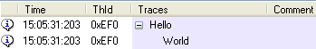

Using TraceToSend

Unlike the C#, Java and Delphi tracetool API, it’s not possible to send hierarchical traces using the Send() method.
The reason is that the Send() method return “void”.
The Programmer don’t have to free object when calling Send().
To create hierarchical traces, use the TraceToSend->Indent() method or use the TraceNodeEx class.

Using TraceNodeEx

// create a new trace with no parent
TraceNodeEx * Node1 = new TraceNodeEx () ;
Node1->leftMsg = "Hello" ;
Node1->Send() ;

// create Node2 as a child of Node1
TraceNodeEx * Node2 = Node1->CreateChildEx ("world") ;
Node2->Send() ;

// create Node3 as a child of Node2
TraceNodeEx * Node3 = new TraceNodeEx (Node2) ;
Node3->leftMsg = "from C++" ;
Node3->Send() ;

delete Node1 ;
delete Node2 ;
delete Node3 ;

Hierarchical traces using Ident and UnIndent

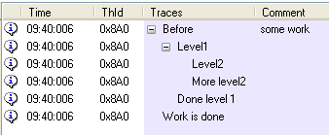

The Ident() function add a message to the specified node.
UnIndent with or without a message return to previous level.
This can be used for call stack tracing or loop traces.
Indent can be used on a specific node or one of the root (debug, warning, error)

Using TraceToSend

TTrace::Debug()->Indent ("Before", "some work");
TTrace::Debug()->Indent ("Level1") ;
TTrace::Debug()->Send ("Level2") ;
TTrace::Debug()->Send ("More level2") ;
TTrace::Debug()->UnIndent ("Done level 1") ;
TTrace::Debug()->UnIndent ("Work is done") ;

Overrides traces : Use one of the ResendXXX or AppendXXX to modify existing text node

Using TraceToSend

Resend and Append is not possible with the C++ version, use TraceNodeEx

Using TraceNodeEx

TraceNodeEx * node1 = TTrace::Debug()->CreateChildEx("Start 1 ..") ;
node1->Send() ;

node1->Append ("Done 1") ; // append left part
node1->Resend (NULL, "Done 2") ; // resend right part

Dump

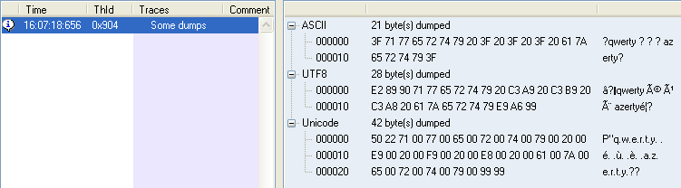

Using TraceToSend

char buffer [100] ;
sprintf (buffer, "%u" , GetCurrentProcessId()) ;

TTrace::Debug()->SendDump ("Dump test", NULL , "Dump" , buffer , 30) ;

Using TraceNodeEx

char buffer [100] ;
sprintf (buffer, "%u" , GetCurrentProcessId()) ;

TraceNodeEx * node ;
node = TTrace::Debug()->CreateChildEx("Dump test") ;
node-> AddDump ("Dump", buffer, 0 , 30) ;
node->Send() ;

TraceNodeEx Members

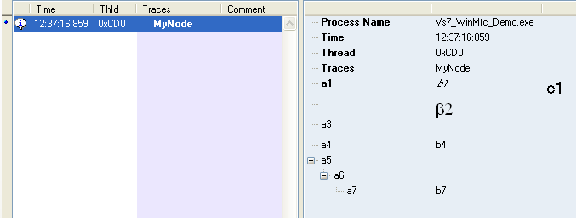
// extended Node with members
TraceNodeEx * node = TTrace::Debug()->CreateChildEx("MyNode") ;
node->AddFontDetail (3,true) ; // change the "MyNode" trace caption to bold
node->Members()
->Add ("a1" , "b1" , "c1") // add member // a1 | b1 | c1
->SetFontDetail (0,true) // a1 bold
->SetFontDetail (1,false,true) // a2 Italic
->SetFontDetail (2,false,false,-1,15) ; // a3 Size 15
node->Members()
->Add (NULL , "b2" ) // add member // | b2 |
->SetFontDetail (1,false,false,-1,15,"Symbol") ; // b2 font Symbol
node->Members()
->Add ("a3") ; // add sub member // a3 | |
node->Members()
->Add ("a4" , "b4" ) ; // add sub member // a4 | b4 |
node->Members()
->Add ("a5") // add member // a5 | |
->Add ("a6") // add sub member // a6 | |
->Add ("a7", "b7") ; // add sub sub member // a7 | b7 |
// finally send the node
node->Send() ;
delete node ;

Multiple windows sample

WinTrace * MyWinTrace ;

MyWinTrace = new WinTrace("MyId" , "MyTitle") ; // create a new window
MyWinTrace->DisplayWin() ; // ask the viewer to display it in front
MyWinTrace->Debug()->Send ("Hello", "World") ; // send traces to a specific window
MyWinTrace->SaveToXml("c:\\log2.xml"); // save all the traces to XML

Note : the main page is also a WinTrace object. To save all messages use the following command:

TTrace::WindowTrace()->SaveToXml (“Main traces.xml”) ;

Multiple Column support

Multi column is not supported in the main trace window, since many applications (and in different languages) cannot share the main window in “classic” mode and in “multi column” mode.

You must then create a window trace and set the columns titles. (with just a few lines)
In that mode, of course, you lose the automatic thread name and date. You must send them yourself if you need to.
Sending many columns of text is performed with the same API as for simple trace.
Just add a tabulation (“\t”) between the different columns.

Here is an example :

WinTrace * MulticolWintrace ;

MulticolWintrace = new WinTrace("MCOLID" , "MultiCol trace window") ; // create the window
MulticolWintrace->SetMultiColumn () ; // set the window to multi column mode.
MulticolWintrace->SetColumnsTitle("Column A \t Column B \t Column C "); // add columns title
MulticolWintrace->DisplayWin() ; // change the active window (optional)

Once initlialized, use the WinTrace instance to send data:

MulticolWintrace->Debug()->Send ("Col1 \t Col2 \t Col3") ; // columns data must separated by tabulations

API documentation overview

The framework defines a lot of public classes, but you need to learn only the TraceToSend class for to the majority of the traces.
Traces can be done in 1 line of code :
TTrace::Debug()->Send ("Hello C++");

The following diagram exposes the public classes. See the help file for full API documentation.
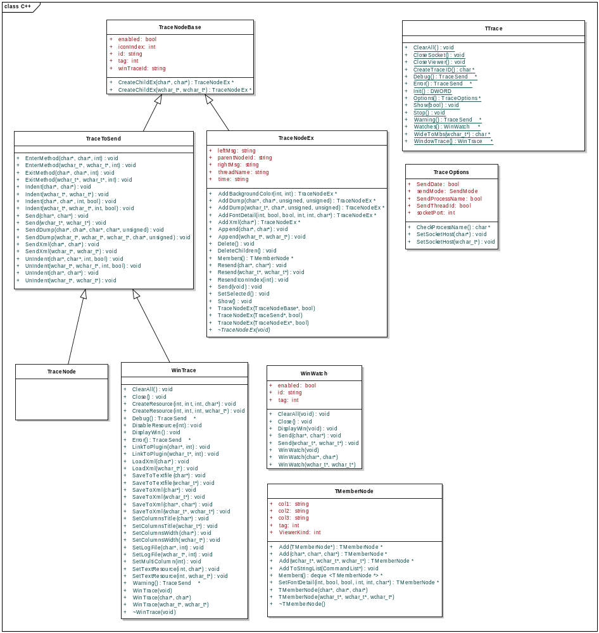

See the cpp-Tracetool.chm help file for classes details.

TTrace

TTrace is the entry point for all traces. He gives 3 'TraceToSend' doors: Warning, Error and Debug.
Theses 3 doors are displayed with a special icon. All of them have the 'enabled' property set to true.
You can set it to false to limit logging. That class is fully static.

This class also represent the viewer:
- Clear messages on the main window.
- Show / hide / close the viewer.
- Give access to the main trace window, the main watch window
- Give access to the main debug, warning and error node.

TTraceOptions

Options for the traces, accessible from TTrace::Options()
- Change the way traces are send : windows messages or socket messages
- Change Socket host and port
- Indicate if the process name must be send. Displayed on the status bar. Default is false.
- Indicate if the date must be send.
The default Host is LocalHost on the 8090 port.

TraceToSend

This class is abstract. You don’t have to create a descendant class or object yourself.
The API provides predefined TraceToSend objects and some ways to create TraceToSend objects.

The TTrace ::Debug , Warning() and Errors() object for example are TraceToSend descendant objects :

TTrace ::Debug->Send (“Hello”, “World”) ;

This class allow you to:
- send simple messages (1 or 2 columns).
- send indented messages (see Indent, UnIndent, EnterMethod and ExitMethod).
- Send dump and xml.

Unlike the C#, Java and Delphi libraries, the Send and Indent methods don’t return a trace node.
It’s then not possible to change the trace using Append and Resend methods.
Theses operations are possible using the TraceNodeEx class.

TraceNode

This class exist only for compatibility with other tracetool client API. TraceNode extend TraceToSend without adding any member.
In other client API, TraSend functions and the TraceNodeEx.send method return a TraceNode object, but since C++ don’t support garbage collection, this functionality is not implemented

TraceNodeEx

Alternate ways to send traces: prepare a TraceNodeEx with all properties and then send it.
TraceNodeEx inherits from TraceNode.

To send a trace perform the following steps :
- Construct a TraceNodeEx giving a TraceNode parent in parameter.
- Change the rightMsg, leftMsg strings, set icon index, add members ("info" trace panel), add dumps and font details.
- Send the trace to the viewer using the Send() method.

Once the node is send, you can :
- Resend texts.
- Append texts.
- Show or set it as selected.
- Delete it or delete children’s.

TMemberNode

TMemberNode represent a node information in the "info" trace panel. Members are available in the TraceNodeEx class.
To create TMemberNode object :
- Use constructor, giving col1,col2 and col3 in parameter , then add this object to the parent member.
- Call one of the Add methods from the parent to create members.

WinTrace

Represent a trace window in the viewer.
The main trace window object is accessible from TTrace:: WindowTrace().
You can create new window using constructors.

WinTrace objects let you manage traces in that window :

- Clear messages
- Set log file
- Save to text or xml files
- Load from xml files
- Change columns

WinTrace * MyWinTrace ;
// create a new trace window
MyWinTrace = new WinTrace("MyId" , "MyTitle") ;

// Ask the viewer switch to the specified window (optional)
MyWinTrace->DisplayWin() ;

// send a message to the trace window
MyWinTrace->Debug()->Send ("Hello", "World") ;

MultiColum sample :
WinTrace * MulticolWintrace ;
MulticolWintrace = new WinTrace("MCOLID" , "MultiCol trace window") ;
MulticolWintrace->SetMultiColumn () ; // must be called before calling setColumnsTitle
MulticolWintrace->SetColumnsTitle("Column A \t Column B \t Column C ");
MulticolWintrace->DisplayWin() ;

int col1 , col2 , col3 ;
col1 = rand() ;
col2 = rand() ;
col3 = rand() ;
sprintf (buffer,"%d\t%d\t%d", col1 ,col2 ,col3) ;
MulticolWintrace->Debug()->Send (buffer) ;

WinWatch

Represent a Watch window in the viewer. The main Watch window can be accessed using TTrace::Watches()

Watches are languages independents: you can send a C++ Watch to the viewer that can be changed by a Java application.
Unlike the other languages supported by TraceTool, only string value can be displayed.

// clear main watch window
TTrace::Watches()->ClearAll() ;

// display main watch window
TTrace::Watches()->DisplayWin() ;

// send watch to main watch window
TTrace::Watches()->Send ("test2" , TTrace::CreateTraceID()) ;

// create a new watch window
WinWatch * MyWinWatch = NULL ;
MyWinWatch = new WinWatch ("MyWinWatchID" , "My watches") ;

SYSTEMTIME Time;
char buffer [MAX_PATH] ;

GetLocalTime(&Time);
sprintf(buffer, "%02d:%02d:%02d:%03d", Time.wHour, Time.wMinute, Time.wSecond, Time.wMilliseconds);

MyWinWatch->Send ("Now" , buffer) ;

// display the new watch window
MyWinWatch->DisplayWin() ;

Extend TraceTool with plugins

You can extend TraceTool functionalities using plugins.
Plugins can be written in Dot net, Java or in any other language that can create a classic win32 DLL (C++ , Delphi,…)
With plugins, you can add for example key logger, registry logger or protocol analyser to TraceTool without having to create a separated application.

Plugins receive some user interface events. You can change the original behaviour or prevent them to occur.
For example, when a user when to clear a “fixed” node, the plugin receive the event , and discard the action.
With the plugin API , you can create new labels, buttons or menu items for a specified trace window or discard them.
A clipboard logger plugin can, for example, disable the COPY button in the ‘Clipboard’ trace window.

An ODBC logger plugin can add an ‘Option’ button on the ‘ODBC’ trace window. The plugin will receive an event when the user click on the button and show a dialog box.

Plugins send command to TraceTool using the classic TraceTool framework (WinTrace object).
The plugin API manipulate resources and actions.

Tracetool resources:

CST_ACTION_CUT | Cut. Same as copy then delete
CST_ACTION_COPY | Copy
CST_ACTION_DELETE | Delete selected
CST_ACTION_SELECT_ALL | Select all
CST_ACTION_RESIZE_COLS | Resize columns
CST_ACTION_VIEW_INFO | View trace info
CST_ACTION_VIEW_PROP | View properties
CST_ACTION_PAUSE | Pause
CST_ACTION_SAVE | SaveToFile
CST_ACTION_CLEAR_ALL | Clear all
CST_ACTION_CLOSE_WIN | Close win
CST_ACTION_LABEL_INFO | TracesInfo label
CST_ACTION_LABEL_LOGFILE | LabelLogFile label
CST_ACTION_VIEW_MAIN | View Main trace
CST_ACTION_VIEW_ODS | ODS
CST_ACTION_OPEN_XML | XML trace -> Tracetool XML traces
CST_ACTION_EVENTLOG | Event log
CST_ACTION_TAIL | Tail

Resource type :

CST_RES_BUT_RIGHT | Button on right
CST_RES_BUT_LEFT | Button on left
CST_RES_LABEL_RIGHT | Label on right
CST_RES_LABELH_RIGHT | Label on right HyperLink
CST_RES_LABEL_LEFT | Label on left
CST_RES_LABELH_LEFT | Label on left hyperlink
CST_RES_MENU_ACTION | Item menu in the Actions Menu
CST_RES_MENU_WINDOW | Item menu in the Windows Menu.  Call CreateResource on the main win trace to create this menu item

Here are the 4 specifics WinTrace functions :

void CreateResource (int ResId , int ResType , int ResWidth , char * ResText = NULL)
void CreateResource (int ResId , int ResType , int ResWidth , wchar_t * ResText = NULL)

Create a ‘Plugin’ resource (Button , label or menu item) for the window.
ResId is the resource Id . Must be >= 100
ResType is the resource
ResWidth is the resource width. Applicable only to button and labels
ResText is the resource text

void DisableResource (int ResId)
Disable tracetool or user created resources.
ResId is the user or tracetool resource Id to disable.

void SetTextResource (int ResId, char * ResText)
void SetTextResource (int ResId, wchar * ResText)
Set the text of a resource (Tracetool or user created).
ResId is the resource Id . Must be >= 100
ResText is the resource text

void LinkToPlugin (char * PluginName, int flags)
void LinkToPlugin (wchar * PluginName, int flags)
Attach a winTrace to a plugin.
Many winTrace can be attached to a plugin. Note that a plugin don't need to be attached to a WinTrace.
The plugin is identified by his internal name (not dll name). When linked, the plugin can receive event (see ITracePLugin).
PluginName is the plugin name
flags is a combinaison of CST_PLUG_ONACTION , CST_PLUG_ONBEFOREDELETE , CST_PLUG_ONTIMER.
To reduce plugin communication, you can ask TraceTool to call only the “OnBeforeDelete” plugin function

Communication between TraceTool and the plugin.

C++ plugins are a special case : you can create plugins using the TraceTool for Dot Net framework
or create a classic Dll and use the non managed C++ framework.

You must create a Dll that export theses 6 functions.
OnAction(), OnBeforeDelete() and OnTimer() functions events are NOT mandatory.

procedure GetPlugName (lpPlugName: PChar) stdcall ;
Get the plugin name

function OnAction (WinId : PChar ; ResourceId : integer; NodeId : PChar) : BOOL stdcall ;
Called when the user click on a button, label or menu on a WinTrace.
The plugin must call WinTrace.LinkToPlugin with CST_PLUG_ONACTION in order to receive this event.
WinId is the Wintrace Id
ResourceId is the User created resource or a tracetool resource.See the Tracetool resources table above
NodeId is the node id of the current selected trace (can be empty)
Return value :
when true : tracetool perform the default action
when false : tracetool don't perform any action

function OnBeforeDelete (WinId : PChar ; NodeId : PChar) : BOOL stdcall ;
Called when a node is to be deleted on a WinTrace
The plugin must call WinTrace.LinkToPlugin with CST_PLUG_ONBEFOREDELETE in order to receive this event.
WinId is the WinTrace Id
NodeId is the node id of the current selected trace
Return value :
when true : TraceTool delete the node
when false : TraceTool don't delete the node

procedure OnTimer() stdcall ;
Called every 500 ms. Can be used for example to refresh labels
The plugin must call LinkToPlugin with CST_PLUG_ONTIMER in order to receive this event

procedure Start() stdcall ;
Initialise the plugin. Called after TraceTool load the plugin

procedure Stop() stdcall ;
Stop the plugin (free any resources before unloading)

Installation.

Unlike Dot Net and Java plugins, non managed plugins don’t need specific loader.
Your plugin can be at any location. Use the TraceTool Option dialog to add plugin or change the TraceTool XML configuration file.

Sample plugin.

The “SamplePlugin” folder , in the CPP distribution , contain a short C++ sample plugin.
Here are some functionalities demonstrate in the DLL:

- The plugin add a label, a button and an item menu to a WinTrace object and receive user events.
- Some nodes are protected by the plugin : no suppression is allowed.
- User Actions are added under the ‘Action’ trace node.
- The ‘Close’ action is not permitted by the plugin
- The last deleted node Id is displayed.
- The plugin receive the Timer event and display the time on a specific node and on a custom Label resource.

The ‘CppNetPlugin’ project in the Dot net distribution is a mixed DLL that implement plugin as a classic DLL but use the managed TraceTool library to communicate with the viewer.

